

**Tribhuvan University**

**Faculty of Humanities and Social Sciences**

**The Times Int’l College**

## SUPERVISOR’S RECOMMENDATION

I hereby recommend the project titled **“Net Bazaar”**, prepared under my supervision by **Sujan Katuwal**, in partial fulfillment of the requirements for the degree of Bachelor of Computer Application, for final evaluation.

**…………………**

**SIGNATURE**

**Vishal Joshi**

**Supervisor**



**Tribhuvan University**

**Faculty of Humanities and Social Sciences**

**The Times Int’l College**

**LETTER OF APPROVAL**

This is to certify that this project prepared by **Sujan Katuwal** entitled “**Net Bazaar”** in partial fulfillment of the requirements for the degree of Bachelor in Computer Application has been evaluated. In our opinion, it is satisfactory in the scope and quality as a project for the required degree.

|  |  |
| --- | --- |
| **……………………**  **Vishal Joshi**  **Supervisor**  **The Times Int’l College** | **……………………..**  **Nirdosh Shrestha**  **Coordinator**  **The Times Int’l College** |
| **……………………**  **Internal Examiner** | **………………...…..**  **External Examiner** |

## ACKNOWLEDGEMENT

I am very grateful to the Department of Computer Application, The Times College, for providing me with the opportunity to undertake a major project as part of my third-year curriculum.

I would like to express my sincere appreciation and deep sense of indebtedness to my esteemed supervisor, **Mr. Vishal Joshi**, for his continuous encouragement, invaluable guidance, and for taking time out of his busy schedule to monitor and review the progress of my project.

I also extend my heartfelt thanks to my peers and to everyone who, directly or indirectly, supported me in successfully completing this project.

Sujan Katuwal

## ABSTRACT

E-commerce, short for electronic commerce, refers to the digital buying and selling of goods and services through online platforms. It plays a vital role in the modern economy by enabling businesses to reach a global audience and allowing consumers to shop conveniently from anywhere at any time. An E-commerce System is a software-based solution designed to facilitate seamless transactions between buyers and sellers, integrating key components such as product listings, user authentication, shopping cart functionality, secure payment gateways, and order tracking mechanisms. The system allows sellers to manage their inventory, publish products, and monitor orders, while customers can browse, search, and purchase with ease. Real-time product updates and responsive design ensure a smooth and intuitive user experience across all devices. Admin functionalities provide control over user roles, transaction monitoring, and system configuration. Security features such as encryption and verification protocols safeguard sensitive data during transactions. Automation of sales processes increases operational efficiency, reduces manual workload, and enhances accuracy. By streamlining the end-to-end commerce cycle, this system supports both individual entrepreneurs and businesses in scaling their digital presence effectively.

**Keywords:**

***Net Bazar****, Online Shopping, Fashion E-commerce, Affordable Clothing, User-Friendly Design, Vendor Management, Customer Support, Digital Retail*

Contents

SUPERVISOR’S RECOMMENDATION I

ACKNOWLEDGEMENT III

ABSTRACT IV

LIST OF ABBREVIATIONS VI

CHAPTER 1 1

INTRODUCTION 1

1.1 Introduction 1

1.2 Problem Statement 1

1.3 Objective 1

1.4 Scope and Limitations 2

1.5 Report Organization 2

CHAPTER 2 3

BACKGROUND STUDY AND LITERATURE REVIEW 3

2.1 Background Study 3

2.2 Literature Review 3

CHAPTER 3 5

SYSTEM ANALYSIS AND DESIGN 5

3.1 System Analysis 5

3.1.1 Requirement Analysis 6

I. Functional Requirements 6

II. Non-Functional Requirement 7

3.1.2 Feasibility Analysis 8

3.1.3 Data Modelling(ER-Diagram) 9

3.1.4 Database Schema 10

3.1.5 Interface Design (UI Interface/ Interface Structure Diagrams) 11

CHAPTER 4 14

CONCLUSION AND FUTURE RECOMMENDATION 14

5.1 Lessons Learned / Outcome 14

5.2 Conclusion 14

5.3 Future Recommendations 14

APPENDICES 16

16

REFERENCES 17

## LIST OF ABBREVIATIONS

**CSS Cascading Style Sheet**

**DFD Data Flow Diagram**

**ER Entity Relationship**

**HTML Hypertext Markup Language**

**HLD High Level Design**

**JS JavaScript**

**LLD Low level Design**

**PHP Hypertext preprocessor**

**SQL Structured Query Language**

**UI User Interface**

**XAMPP Cross-Platform, Apache, MySQL, PHP, Per**

## CHAPTER 1

## INTRODUCTION

### 1.1 Introduction

E-commerce refers to the buying and selling of goods and services over the internet. It has transformed the traditional marketplace by enabling businesses and consumers to engage in transactions from anywhere and at any time. In today’s digital age, the use of internet technologies has become increasingly prominent across various sectors, which has motivated us to harness these advancements within the commercial domain.

The motivation behind this project is to address common challenges in the traditional commerce system—such as limited reach, time constraints, manual inefficiencies, and lack of automation. These issues often lead to delays, errors, and data mismanagement. To overcome these limitations, we have developed a web-based e-commerce platform that allows sellers to manage their products and services online while providing customers with a smooth and user-friendly shopping experience.

The system we have built is developed using free and open-source technologies available on the internet. These technologies include HTML, CSS, JavaScript, PHP, and MySQL, all of which are widely supported, community-driven, and cost-effective. This approach ensures scalability, maintainability, and accessibility for both developers and end users.

### 1.2 Problem Statement

* Many small businesses lack an online platform, limiting their market reach.
* Manual processes cause delays, errors, and poor inventory management.
* Customers face difficulty accessing products and services efficiently.

### 1.3 Objective

The design of the e-commerce website aims to achieve the following objectives:

* To provide a user-friendly platform for buying and selling products online.
* To help sellers manage inventory, orders, and customer data efficiently.
* To expand business reach by enabling 24/7 access to products and services.

### 1.4 Scope and Limitations

This project is designed to automate the buying and selling process through a web-based e-commerce platform. It focuses on providing an easy-to-use interface for users to browse, purchase, and manage products online. The system allows sellers to list products, manage orders, and track sales.

However, the project has the following limitations:

* It does not include integration with third-party payment gateways (only basic payment handling is implemented).
* Delivery tracking and logistics are not fully automated.
* The system is intended for small to medium-scale use and may require scaling for high-traffic environments.

### 1.5 Report Organization

The report document contains five chapters including:

* **Chapter 1: “Introduction”** – This chapter describes the introduction of the built system. It also contains problem statement, objective, scopes and limitations of Expense Management System.
* **Chapter 2: “Background Study and Literature Review”** – This chapter describes the background of the study and reviews the existing literature relevant to the project.
* **Chapter 3: “System Analysis and Design”** – This chapter presents the System Analysis and Design including Requirement Analysis and Feasibility Analysis.
* **Chapter 4: “Conclusion and Future Recommendations”** – The concluding chapter summarizes the successful completion of the project and discusses future developments and plans for its expansion.

## CHAPTER 2

## BACKGROUND STUDY AND LITERATURE REVIEW

### 2.1 Background Study

Traditional methods of selling goods and managing inventory are often slow, error-prone, and dependent on manual processes. As customer demand and product variety increase, businesses struggle to manage transactions, track stock, and maintain accurate records. Manual handling of these tasks leads to inefficiencies, delayed service, and missed opportunities.

With the rapid advancement of digital technologies and the growing popularity of online shopping, consumers now prefer fast, accessible, and reliable e-commerce solutions. To meet these expectations, we developed a web-based platform that allows users to browse products, place orders, and manage accounts online. For sellers, the system simplifies product management, order tracking, and customer engagement through a centralized dashboard.

E-commerce systems have evolved significantly, moving from basic digital catalogs to fully automated, dynamic platforms. These systems improve business operations by reducing human error, increasing efficiency, and enabling 24/7 availability. The adoption of such platforms is essential for staying competitive in today’s fast-paced digital economy.

### 2.2 Literature Review

Various articles, research papers, and project reports have been reviewed in the preparation of this report, focusing on the development and evolution of e-commerce platforms. A brief summary of these references is outlined below:

According to Chaffey et al. [1], traditional brick-and-mortar commerce lacks the flexibility, speed, and convenience offered by e-commerce platforms. Manual inventory handling, limited customer reach, and time-bound operations hinder business growth and scalability. E-commerce systems address these limitations by automating transactions, providing real-time data, and enabling global accessibility.

Singh and Patel [2] emphasize that online shopping behavior has increased dramatically due to advancements in web technologies and mobile accessibility. Their study highlights that user-friendly interfaces, secure payment systems, and product personalization are key components in increasing user satisfaction and retention on e-commerce platforms.

Research by Al-Sharafi and Ibrahim [3] discusses the impact of cloud-based e-commerce solutions on small to medium enterprises (SMEs). They found that such platforms reduce operational costs, increase customer engagement, and allow for easier system integration with marketing and analytics tools.

Several notable e-commerce systems have gained popularity for their robust features:

* **Shopify**: A cloud-based solution offering customizable storefronts, payment integration, and inventory management [4].
* **WooCommerce**: A plugin-based platform for WordPress that provides flexible product and order management features [5].
* **Magento**: A powerful open-source platform suitable for large-scale operations with high customization capabilities [6].
* **BigCommerce**: Offers scalable e-commerce features with built-in SEO tools, analytics, and third-party integration support [7].

These platforms have set benchmarks for modern e-commerce applications, providing valuable insights into feature prioritization, UI/UX design, and backend automation, which guided the development of our project.

## CHAPTER 3

## SYSTEM ANALYSIS AND DESIGN

### 3.1 System Analysis

Given that this project involves the design and implementation of a web-based e-commerce system, it was essential to consider suitable software development models. These models provide a structured approach to building reliable, scalable, and maintainable software systems. For this project, the **Waterfall Development Model** was adopted due to its clarity, simplicity, and linear structure, which aligns well with the scale of a two-developer team.

#### ****Waterfall Development Model****

The Waterfall model is a traditional and sequential software development methodology where each phase must be completed before moving on to the next. Although the model is linear in structure, feedback loops were incorporated during the development process to refine functionality and correct issues early.

The following stages were followed during the development of the e-commerce platform:

* **Requirement Analysis:** The system requirements were gathered by identifying user needs, business processes, and key features such as product listing, cart management, order processing, and user authentication.
* **System Design:** The overall system architecture, user interface design, and database schema were planned to ensure smooth data flow, usability, and scalability.
* **Implementation and Debugging:** The website was developed using standard web technologies. Individual modules were coded and tested iteratively to reduce errors.
* **Testing and Integration:** Functional testing, UI testing, and user scenario simulation were conducted. The modules were then integrated into a complete system for final validation.

The Waterfall model provided a clear roadmap for development, ensuring that each phase was well-documented and systematically executed, which helped maintain the quality and structure of the system throughout the project lifecycle.

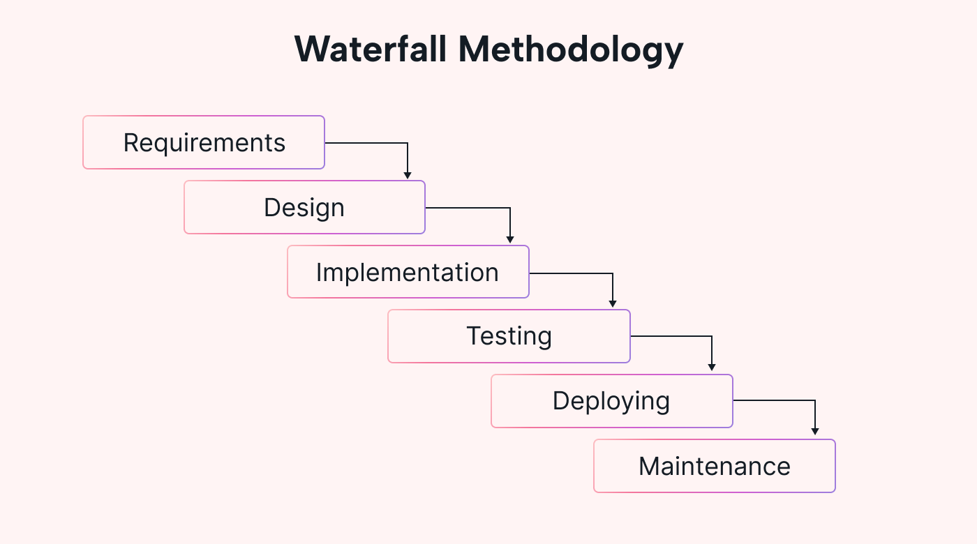

Figure 3.1 Waterfall Methodology

### 3.1.1 Requirement Analysis

Requirement analysis is a fundamental step in determining the overall success of a software system. It involves gathering, analyzing, and defining what the system should accomplish to meet user and business expectations. Requirements are categorized into two types:

* **Functional Requirements**
* **Non-Functional Requirements**

### ****I. Functional Requirements****

The system consists of three primary modules: Admin, User, and Seller. Each module has its own responsibilities and functionality.

**1. Admin Module**

* Admin can approve or reject seller registration requests.
* Admin can manage user and seller accounts.
* Admin can view overall sales reports and product listings.
* Admin can block or unblock suspicious users/sellers.

**2. User Module**

* Users can create and manage their accounts.
* Users can browse products and view product details.
* Users can add products to the shopping cart and place orders.
* Users can view order history and track delivery status.
* Users can leave reviews and rate products.

**3. Seller Module**

* Sellers can register and wait for admin approval.
* Sellers can log in and manage their profiles.
* Sellers can add, edit, or delete product listings.
* Sellers can view and manage customer orders.
* Sellers can view product performance reports.

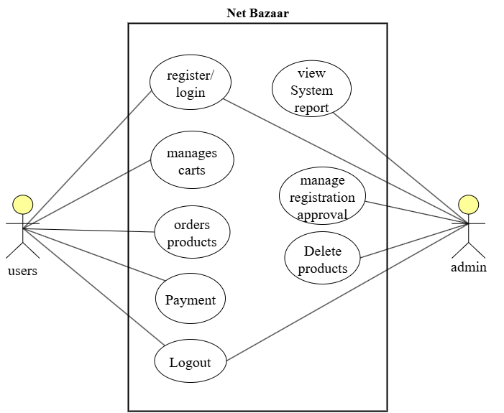

Figure 3.2 Use Case Diagram of Net Bazaar

### II. Non-Functional Requirement

Non-functional requirements define the overall qualities and attributes that the system must possess to ensure efficiency, reliability, and user satisfaction. These requirements influence the user experience and the long-term maintainability of the system. The key non-functional requirements identified for this project are as follows:

**1. Efficiency Requirements**

* The system must provide quick response times, ensuring that product pages load within 2–3 seconds under standard internet conditions.
* Backend operations such as product updates and order processing must be optimized to minimize server load and latency.

**2. Reliability Requirements**

* The system must be available 99% of the time to ensure users and sellers can access their accounts and perform transactions without interruption.
* Data consistency must be maintained in all operations, especially during checkout, payment, and inventory updates.
* Automatic backup mechanisms should be in place to recover from data loss or unexpected failures.

**3. Usability Requirements**

* The system should have a user-friendly interface that is easy to navigate for all user roles (admin, user, seller).
* All interactive elements, such as forms and navigation menus, should be intuitive and responsive across devices.
* The website must support accessibility standards, allowing users with disabilities to interact with the system.

### 3.1.2 Feasibility Analysis

Feasibility analysis is performed to assess the viability of the proposed system from multiple perspectives. It ensures that the project is achievable with the available resources, technology, and time constraints. The analysis for this e-commerce project is categorized as follows:

#### ****i. Technical Feasibility****

The proposed system is technically feasible as it leverages widely available technologies. It requires only basic hardware, a web browser, and internet connectivity. The platform is developed using standard web technologies and open-source tools, ensuring compatibility across devices. The user interface is designed to be minimal and intuitive, making the system technically accessible for both users and developers.

#### ****ii. Operational Feasibility****

The system is operationally feasible and practical for regular use. It is reliable and maintains consistent performance, ensuring a smooth experience for all users—including those with limited technical knowledge. The design prioritizes simplicity, maintainability, and user support. Training requirements are minimal due to the system’s intuitive layout and self-explanatory navigation.

#### ****iii. Economic Feasibility****

The development of the system remains within budgetary constraints, with no additional costs for proprietary tools or licenses. The use of open-source platforms and technologies eliminates the need for expensive software or hardware. Resources such as development tools, frameworks, and hosting environments were freely available, making the system economically sustainable.

#### ****iv. Schedule Feasibility****

The project was developed within a manageable timeframe. Although the data collection phase required extended effort due to sourcing inputs from various customers and sellers, the design, development, and testing phases were completed efficiently within one month. The timeline adhered to the academic project schedule, making it feasible within the allocated period.

### 3.1.3 Data Modelling(ER-Diagram)

The ER diagram uses structured data modeling techniques to outline entity attributes, primary keys, and foreign key relationships essential for maintaining data integrity and consistency. Each entity is represented with its respective attributes and a unique identifier, ensuring efficient data retrieval and relational mapping.

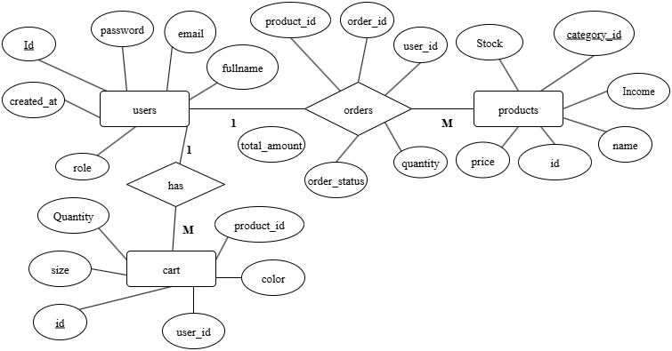

Figure 3.2 ER diagram of Net Bazaar

### 3.1.4 Database Schema

The Database Schema of the Net Bazaar E-Commerce System outlines the structured layout for organizing and managing data efficiently. It is designed to support a scalable multi-user environment that includes customers, sellers, products, orders, and administrators. The schema ensures data consistency, normalization, security, and high performance.

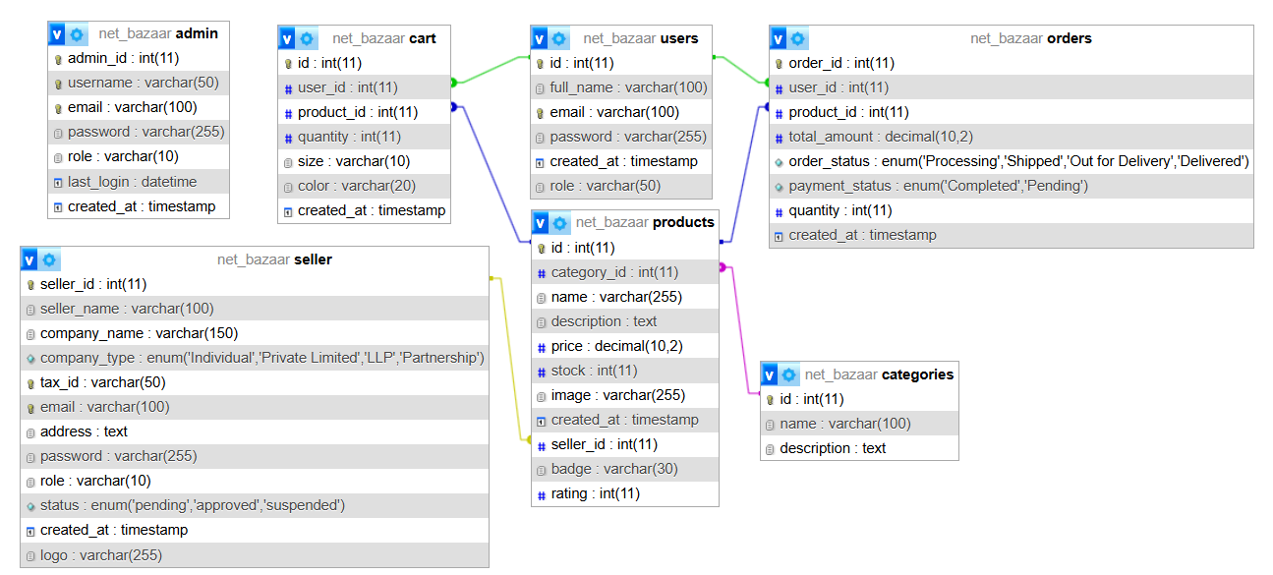

Figure 3.7 Database Schema of Net Bazaar

### 3.1.5 Interface Design (UI Interface/ Interface Structure Diagrams)

The **Interface Design** of the Net Bazaar E-Commerce System is structured to ensure a responsive, intuitive, and accessible user experience across all devices. The system includes role-based interfaces designed for Buyers, Sellers, and Admins. The interface structure prioritizes simplicity, navigation clarity, and real-time interactivity.

**Primary Interfaces:**

* **1. Landing Page**
  + Welcomes users with an overview of the platform.
  + Includes sections for featured products, categories, seller highlights, and login/register buttons.
* **2. Registration Page**
  + Separate sign-up forms for buyers and sellers.
  + Collects relevant user data such as email, password, name, and for sellers—business details and tax ID.
* **3. Login Page**
  + Secure authentication portal for buyers, sellers, and admins.
  + Includes “Forgot Password” and “Remember Me” options.
* **4. Buyer Dashboard**
  + Personalized space for buyers to:
    - Browse products
    - Add to cart and checkout
    - View order history and track orders
* **5. Seller Dashboard**
  + Interface for sellers to:
    - Add, update, or remove products
    - View sales reports and order requests
    - Monitor inventory levels
* **6. Admin Control Panel**
  + Admin-level access to:
    - Approve or reject seller registrations
    - Suspend or reactivate seller accounts
    - Monitor site activity, view reports, and manage users

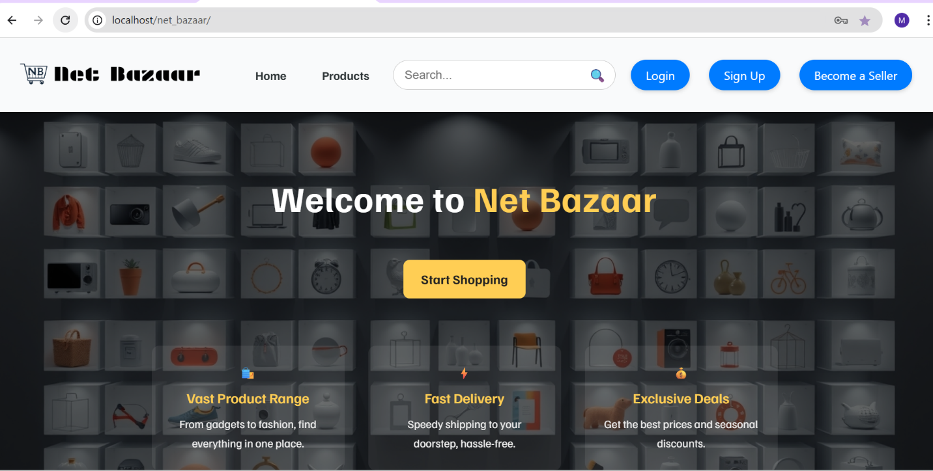

Figure 3.8 Landing page Design of Net Bazaar

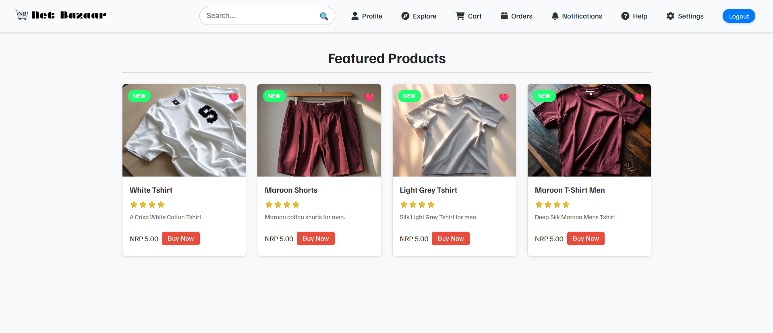

Figure 3.9 User Dashboard design of Net Bazaar

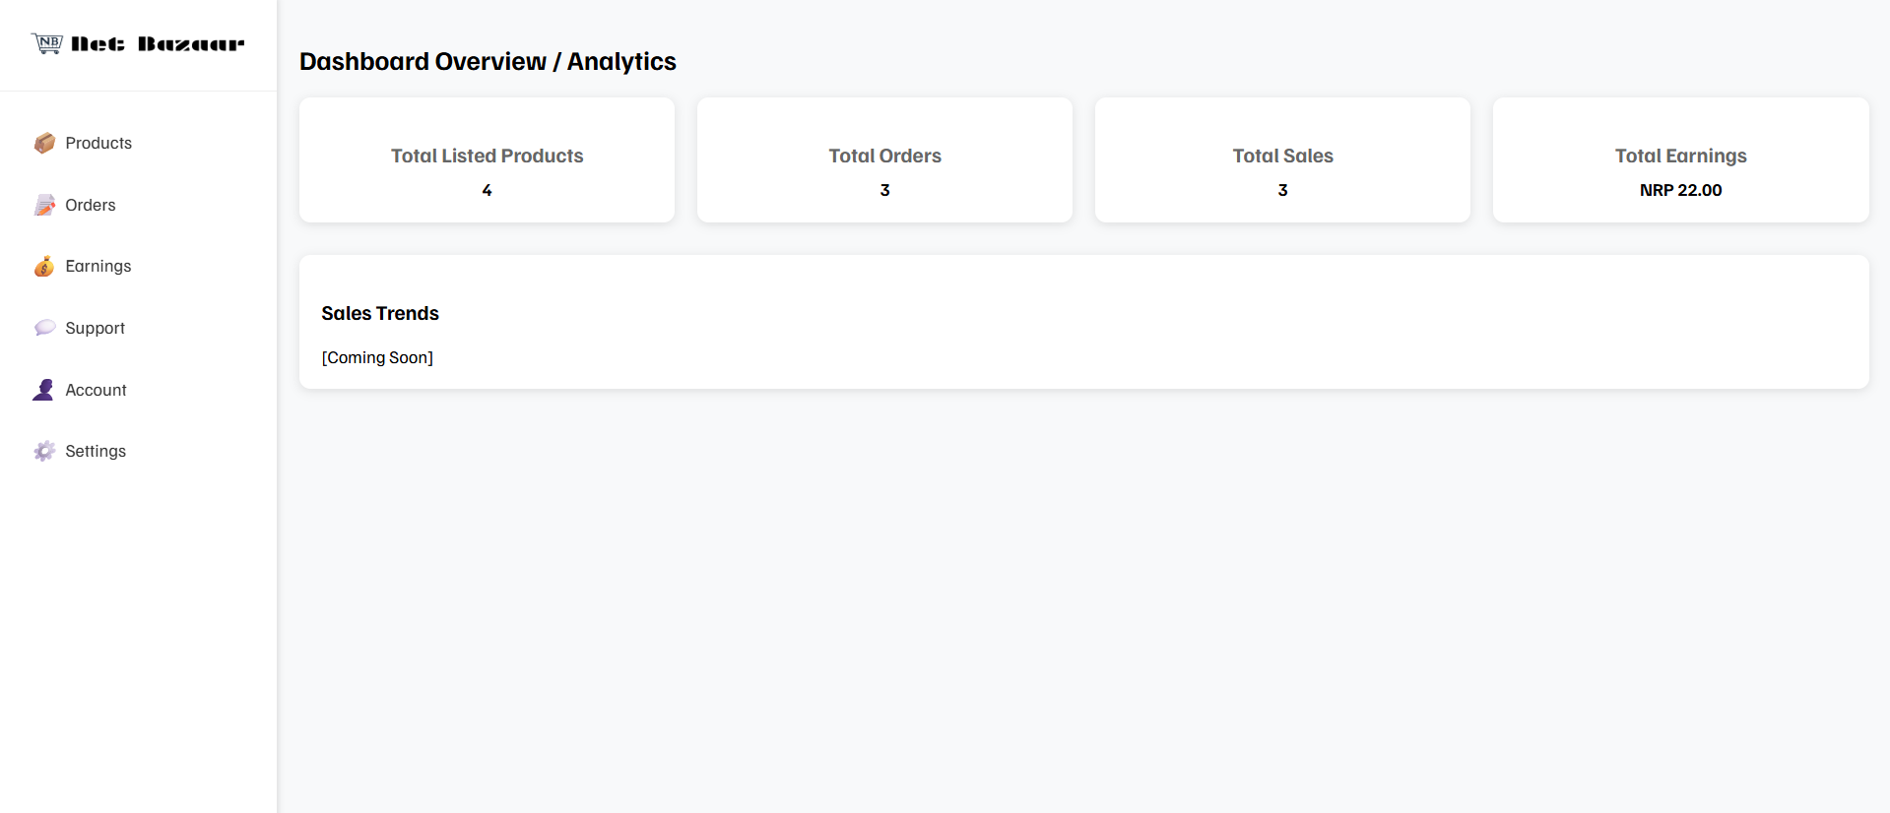

Figure 3.10 Seller Dashboard design of Net Bazaar

## CHAPTER 4

## CONCLUSION AND FUTURE RECOMMENDATION

### 5.1 Lessons Learned / Outcome

Upon completion of the e-commerce platform project, the core objectives were successfully achieved. Users can register through a web-based form and seamlessly browse, list, and manage products online via the website. This digital platform streamlines the buying and selling process, reduces manual overhead, and enhances overall user engagement by providing an accessible, interactive marketplace.

### 5.2 Conclusion

Traditionally, small businesses and individual sellers faced challenges managing their sales and product listings manually or through fragmented systems. This resulted in inefficiencies, errors, and limited market reach. The developed e-commerce platform addresses these issues by providing a centralized, automated solution for product listing, order management, and user interactions. With real-time updates, secure authentication, and an intuitive interface, the system improves operational efficiency for sellers and enhances the shopping experience for buyers. This platform represents a modern, scalable solution that supports business growth and customer satisfaction.

### 5.3 Future Recommendations

Several features and improvements can be introduced to elevate the platform’s functionality and user experience:

* **Enhanced Seller Profiles:** Enable sellers to add detailed company information, branding, and customizable storefronts.
* **Forgot Password and Account Recovery:** Implement secure password reset features to improve accessibility.
* **Order and Sales Reports:** Provide downloadable sales and order reports in multiple formats for better business insights.
* **Responsive Design:** Optimize the website for mobile and tablet devices to expand accessibility.
* **Advanced Search and Filtering:** Integrate robust product filtering and search capabilities to help users find products more efficiently.
* **Integrated Payment Gateway:** Add secure payment options to enable seamless transactions within the platform.

## APPENDICES

## 

Figure 5.1 Home page

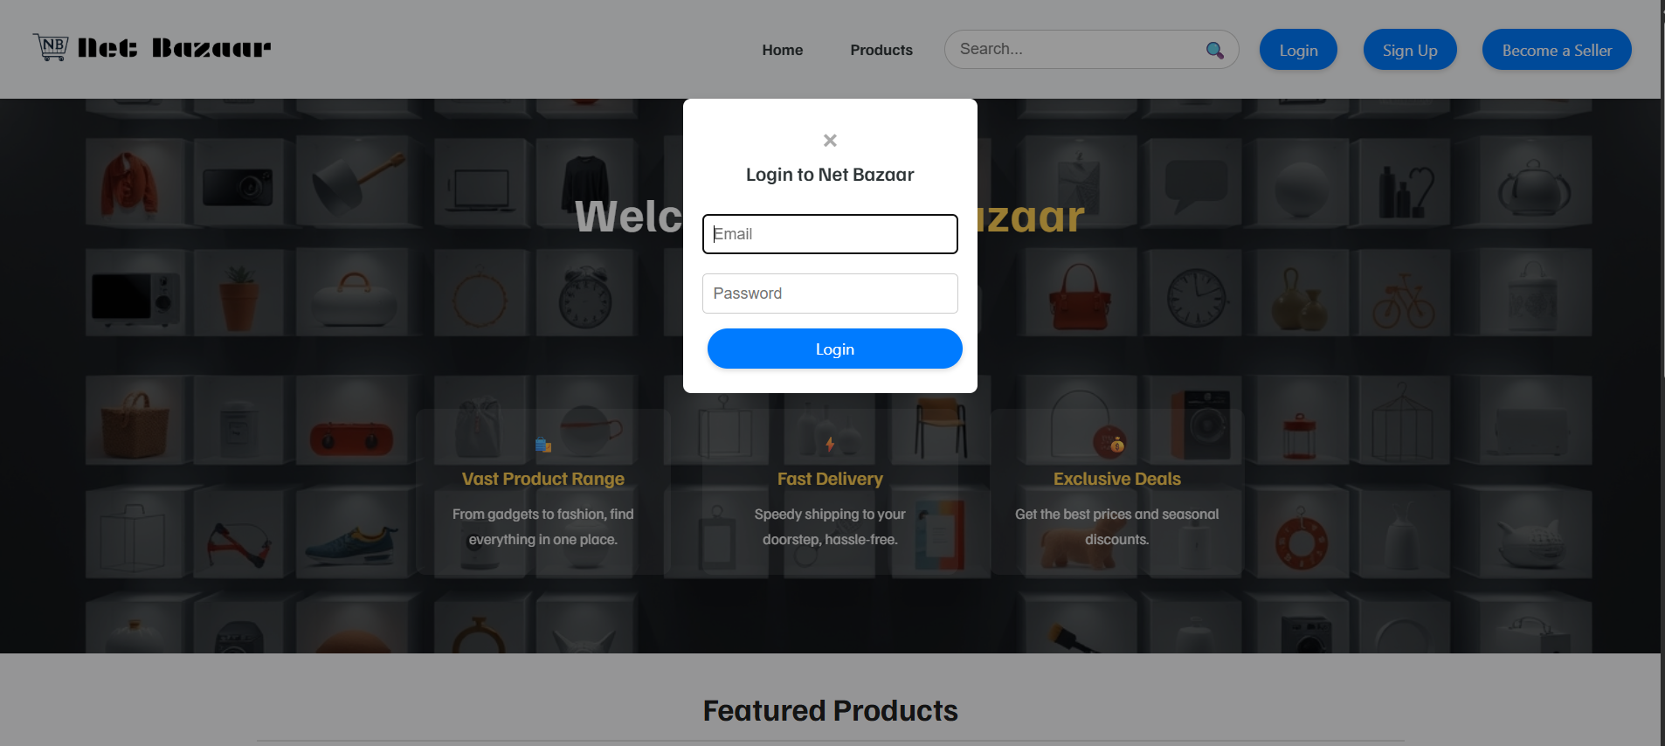

Figure 5.2 login page

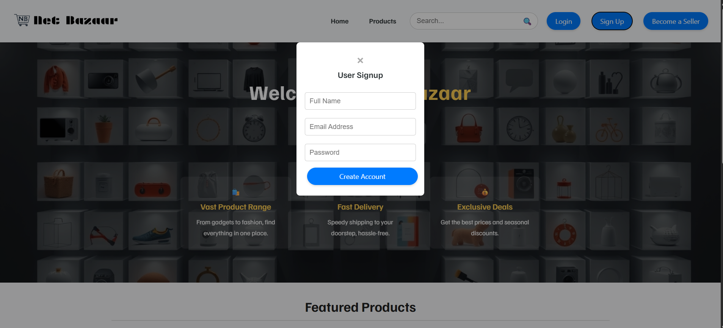

Figure 5.3 Sign Up page

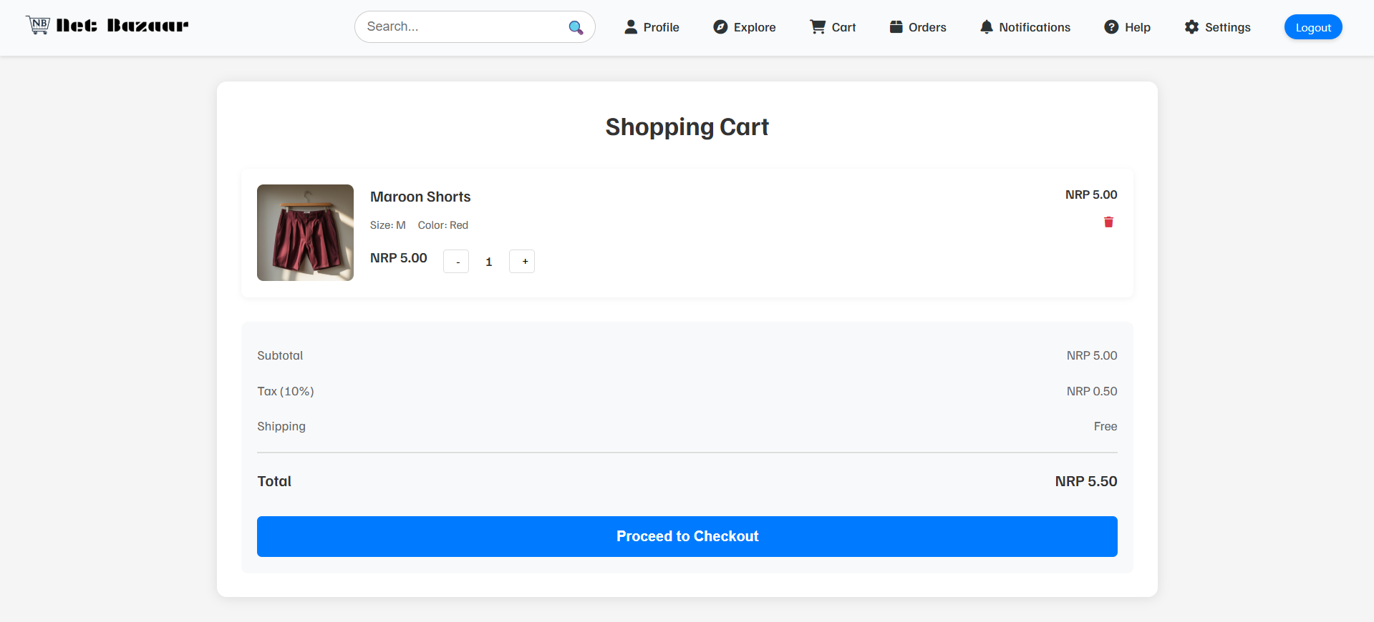

Figure 5.4 Carts Page

## REFERENCES

[1] Laudon, K.C., & Traver, C.G. E-commerce 2023: Business, Technology, Society, 17th Edition. Pearson, 2023.

[2] Turban, E., et al. Electronic Commerce: A Managerial and Social Networks Perspective, 9th Edition. Springer, 2018.

[3] Chaffey, D. Digital Business and E-commerce Management, 7th Edition. Pearson, 2019.

[4] Shopify, [Online]. Available: <https://www.shopify.com/>. [Accessed: 09-Jun-2025].

[5] WooCommerce, [Online]. Available: <https://woocommerce.com/>. [Accessed: 09-Jun-2025].

[6] Magento, [Online]. Available: <https://magento.com/>. [Accessed: 09-Jun-2025].

[7] PayPal, [Online]. Available: <https://www.paypal.com/>. [Accessed: 09-Jun-2025].